Spectrogram Data Augmentation

|  |  |  |
| --- | --- | --- |
| Input | |  | | --- | | Classification Accuracy | |

Convolution

|  |  |  |  |  |
| --- | --- | --- | --- | --- |
| Data size: 2s6%256x1 |  |  |  |  |
| Convolution | Convolution | Comolution | Convolution | layer |
| Filter: 64 | Filter: | Filter: 256 | Filter: 512 |  |

Input

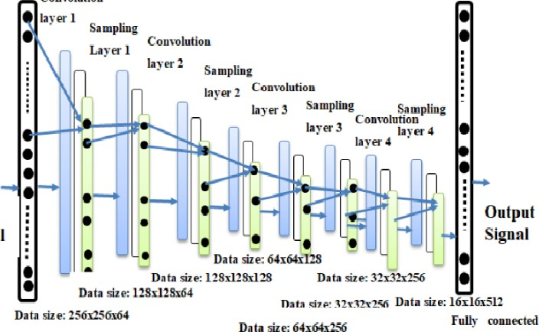

Data

Signal

Fully

Confusion matrix Of VGGNet: Accurac : 98.911%

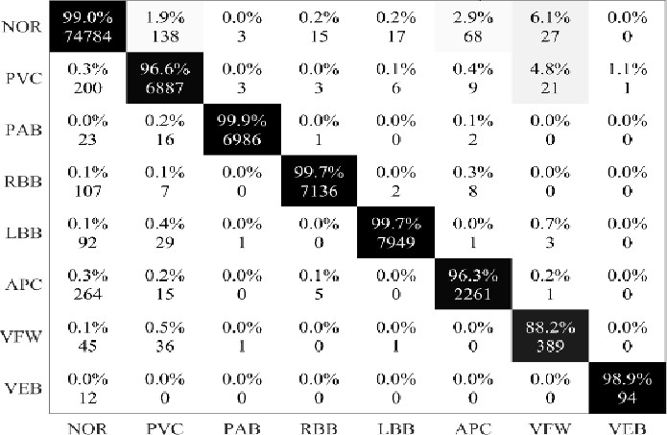

Target Class

